# CS 255 System Design Document Template

This template lays out all the different sections that you need to complete for Project Two. Each section has guidance to prompt your thinking. You will need to continually reference the interview transcript as you work to make sure that you are addressing your client’s needs. There is no required length for the final document. Instead the goal is to complete each section based on what your client’s needs are. Remove this note when you are finished, and replace all bracketed text with the relevant information.

## UML Diagrams

### UML Use Case Diagram

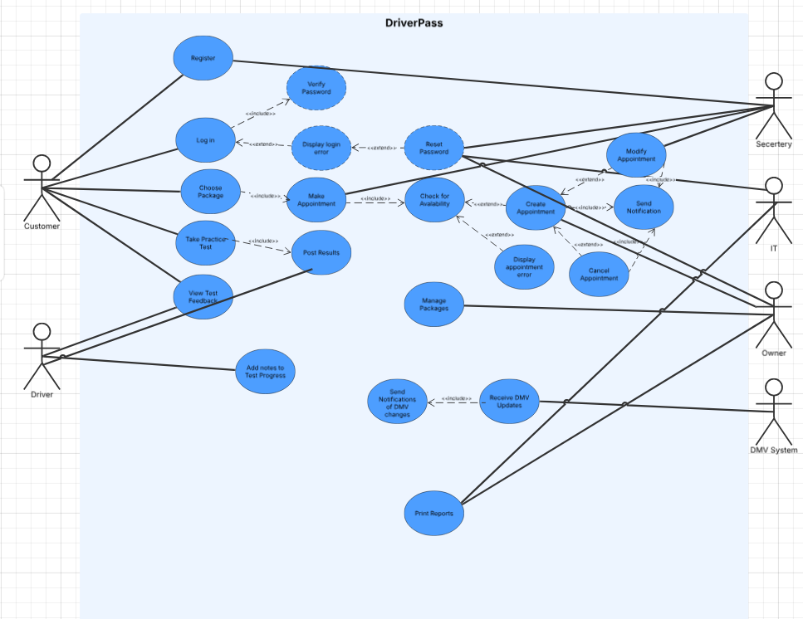

### UML Activity Diagrams

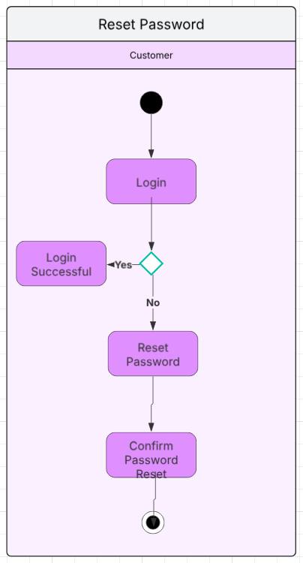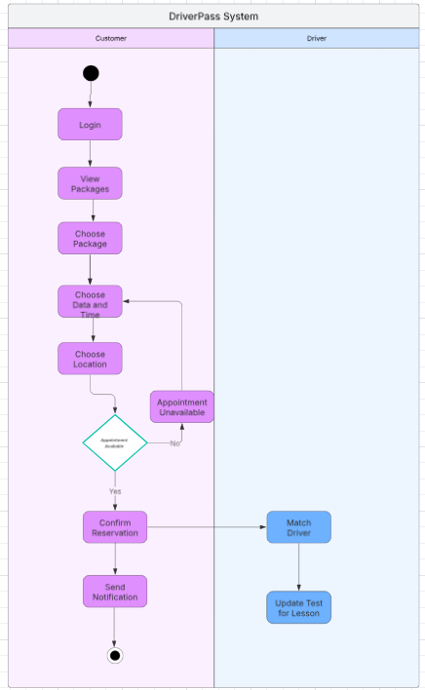

### UML Sequence Diagram

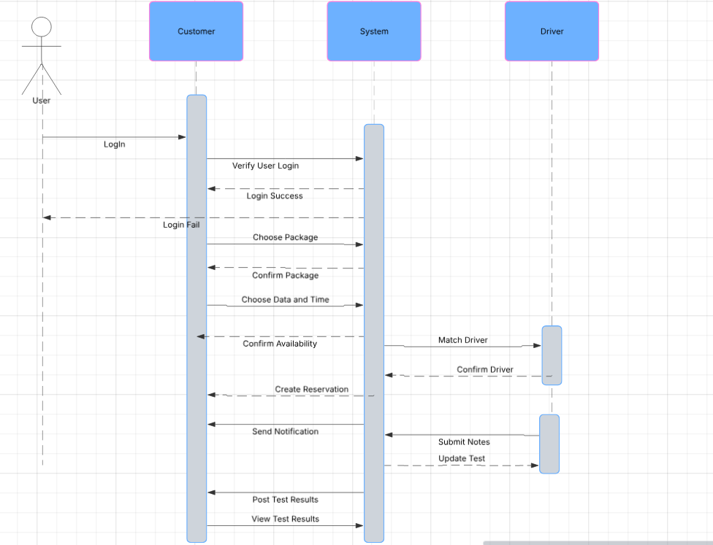

### UML Class Diagram

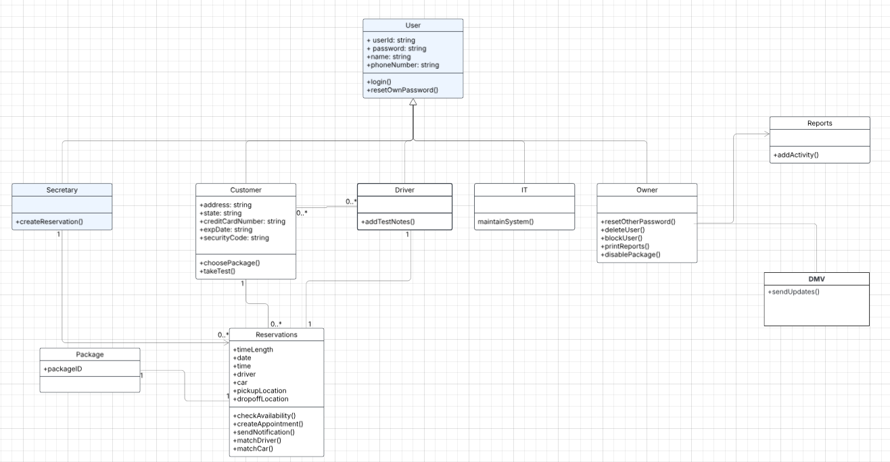

## Technical Requirements

* Computers, laptops, tables, or phones for the facility to access the system
* Reliable server to host the system
* Ticket management to help handle maintenance request
* Encrypted and secure database to store all the customers’ information, reservations, changes to the system, and to track any changes made to the system
* Encrypted login to discourage hacking
* Backups for maintenance or something may happen to the system
* System capable of sending messages or notifications to multiple kinds of devices